# IOP Conference Series: Materials Science and Engineering

**PAPER • OPEN ACCESS**

The Fresnel Coefficient of Thin Film Multilayer Using Transfer Matrix Method TMM

To cite this article: Zahraa Hummam Mohammed 2019 *IOP Conf. Ser.: Mater. Sci. Eng.* **518** 032026

View the [article online](https://doi.org/10.1088/1757-899X/518/3/032026) for updates and enhancements.

# You may also like

* [Mechanical metamaterials with](https://iopscience.iop.org/article/10.1088/1361-665X/abc182) [programmable compression-twist coupling](https://iopscience.iop.org/article/10.1088/1361-665X/abc182) Debkalpa Goswami, Yunlan Zhang, Shuai Liu et al.
* [Stable tissue-mimicking materials and an](https://iopscience.iop.org/article/10.1088/2057-1976/aa922d) [anatomically realistic, adjustable head](https://iopscience.iop.org/article/10.1088/2057-1976/aa922d) [phantom for electrical impedance](https://iopscience.iop.org/article/10.1088/2057-1976/aa922d) [tomography](https://iopscience.iop.org/article/10.1088/2057-1976/aa922d)

Barry McDermott, Brian McGinley, Katarzyna Krukiewicz et al.

* [Symmetry analysis of the numerical](https://iopscience.iop.org/article/10.1088/2040-8978/15/12/125719) [instabilities in the transfer matrix method](https://iopscience.iop.org/article/10.1088/2040-8978/15/12/125719) Jose Miguel Luque-Raigon, Janne Halme, Hernan Miguez et al.

# Recent citations

* + [Numerical Analysis of a Highly Sensitive](https://doi.org/10.1007/s11468-021-01455-0) [Surface Plasmon Resonance Sensor for](https://doi.org/10.1007/s11468-021-01455-0) [SARS-CoV-2 Detection](https://doi.org/10.1007/s11468-021-01455-0)

Syed Mohammad Ashab Uddin *et al*

* + [Analysis of Embedded Optical](https://doi.org/10.3390/s21082787) [Interferometry in Transparent Elastic](https://doi.org/10.3390/s21082787) [Grating for Optical Detection of Ultrasonic](https://doi.org/10.3390/s21082787) [Waves](https://doi.org/10.3390/s21082787)

Chayanisa Sukkasem *et al*

* + [Fiber Optic Sensors: A Review for Glucose](https://doi.org/10.3390/bios11030061) [Measurement](https://doi.org/10.3390/bios11030061)

Jos&#233 *et al*



This content was downloaded from IP address 202.120.16.26 on 19/11/2021 at 02:37

IOP Conf. Series: Materials Science and Engineering **518** (2019) 032026

doi:10.1088/1757-899X/518/3/032026

**The Fresnel Coefficient of Thin Film Multilayer Using Transfer Matrix Method TMM**

## Zahraa Hummam Mohammed1

1Electrical Engineering Department, Al-Mustansiriayah University, Baghdad, Iraq. E-mail: [Zahraah_2005@yahoo.com](mailto:Zahraah_2005@yahoo.com)

**Abstra**[**ct.** When the light incident](mailto:Zahraah_2005@yahoo.com) on a multilayer planar mound, it is reflected, transmitted, and absorbed in the method that derived the Fresnel equations. The metal used in this work is the thin film of gold put on the glass. The properties of the preparation of waveform for dielectric charged surface Plasmon polariton structure of the bearing surface of the carrier plasma were studied using a simple transport matrix method(TMM), The Transfer Matrix Method (TMM) used to calculate the reflection, transmission & absorption for both TE (transverse wave) and TM (magnetic browser for the oblique incident plane wave. The relation between the incident angle with the Fresnel coefficient plotted at the different wavelength regimes (300nm,700nm,1200nm) was plotted using the program of the TMM written in Matlab (R2013). The best result for this Fresnel coefficient in the visible incident plane wave with wavelength=700nm.

**Keywords:** angle of incident, Fresnel coefficients, multiyear thin film, transfer matrix method (TMM).

## Introduction

In the interaction between minerals with electromagnetic radiation has been largely determined by free conduction electrons in the metal. According to the simple Drude model, the free electrons oscillate outside the phase of the electric field. As an attribution, most metals possess a negative buffer constant at the optical frequencies that cause for example reflectivity is very high. Moreover, in optical frequencies the free metal electron gas can maintain the oscillations of surface and volume charge density, plasmon polaritons or plasmons are called with distinct resonance frequencies1.

When the wave falls on the surface of the metal, there is a light interference between two symmetric regions and a split occurs into two waves. The first is with the falling wave next to the light interference called the transmitted wave (T), while the second wave is the reflected wave (R), These processes are called Fresnel coefficient, figure 1 describe the reflection and refraction for two different media 2. 2b. There are two types of polarization depending on the angle of the fall of the wave on the surface of the material. First one is the parallel polarization or p-polarization or TM polarization, two electromagnetic fields are generated from the falling of electromagnetic wave, the electric fields are located on the surface of the material in the x-direction, and the magnetic fields are perpendicular to the surface of the material in the y-direction and move transverse to z-direction3. The second one is perpendicular polarization or s-polarization or TE polarization; the electric fields are perpendicular to the surface of the material in the y-direction and move transverse to the z-direction, and the magnetic fields are located on the surface of the material in the x-direction4.4b. At present, the composite metal structures have been developed remarkably in the industry because of large mechanical Properties

Content from this work may be used under the terms of the Creative Commons Attribution 3.0 licence. Any further distribution of this work must maintain attribution to the author(s) and the title of the work, journal citation and DOI.

Published under licence by IOP Publishing Ltd 1

IOP Conf. Series: Materials Science and Engineering **518** (2019) 032026

doi:10.1088/1757-899X/518/3/032026

instead of other materials. Furthermore, the detection of damage using wave propagation is one of the most interesting topics that attracted the attention of the researchers5. Studies on multilayered structures with substitutions in the layers of material or metal of matter are stimulated by the common known features of flat periodic systems to generate transparent bonds. The alternative way to calculate the optical response of a multi-layer material is transferred matrix method (TMM). In 1945, The Maudelstam has been first discussed the negative refraction of the light and other waves. Veselago in 1968, found that the refraction in one intermediate interface can not only be negative but also reflective. After nearly 30 years since the original work of Veselago, Pendry has proposed various MRI structures 3.

In the last year, V.H.Carrera-Escobedo &H.C.Rosa, highlighted the dependence of the transmittance on the frequency range and angle of the incident of the electromagnetic wave. They found the transition properties of the multilayered structure of the positive media of the refractive index and the negative media of the refractive index using the TMM.6. The objective of this research is to find the accuracy of the wavelength to get the best result for Fresnel coefficient.

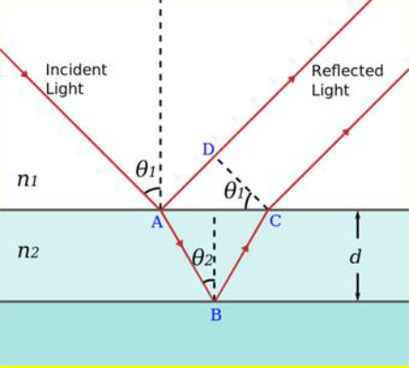

**Figure 1.** describe the reflection and refraction for two different media

## Theoretical Basics

The spread of the electromagnetic wave (EM) in the optical medium is illustrated by Maxwell's four equations 7.

𝜖1𝐸⊥

1

⊥

= 𝜖2𝐸⊥

⊥

2

(1)

�1 = �2

∥ ∥

(2)

𝐸1 = 𝐸2

(3)

�∥

1⁄𝜇

1

�∥

# = 2⁄𝜇

2

(4)

These four equations (1-4) is the basis of the theory of reflection and refraction in the visual interfaces.

With a flat monochrome wave of form 𝐸𝑖 = 𝐸0,𝑖���[𝑖(𝑘𝑖� − �𝑖�)], We can drive the law of Reflection equation 3 8. The Snell’s law of refraction:

�1�𝑖��1=�2�𝑖��2 (5)

Depending on the angle of fall, the type of polarization of the falling wave is determined. The electric

field is vertical (Es) and parallel (Ep) on the falling surface. The Fresnel constants derived from the equations (3 and 4):

� = 𝐸� ,�

𝐸

�

= �1 ��� �1 − �2 ��� �2

� ���� +� ����

(6)

𝑖,�

1 1 2 2

IOP Conf. Series: Materials Science and Engineering **518** (2019) 032026

doi:10.1088/1757-899X/518/3/032026

𝐸�,�

2�1����1

�� =

𝑖,�

𝐸

=

�1����1

+ �2

����2

(7)

𝐸�,�

�2����1 − �1����2

�� =

𝑖,�

𝐸

=

�2����1

+ �1

����2

(8)

𝐸�,�

2�1����1

�� =

𝑖,�

𝐸

=

�2����1

+ �1

����2

(9)

Figure 2 shows an N layer of insulating metal. Each layer has a thickness dl and a refractive index n.

In order to find the formulation structure, the model that used in this research is accident electromagnetic wave from air to glass and gold medium 8.9.10.11.12.

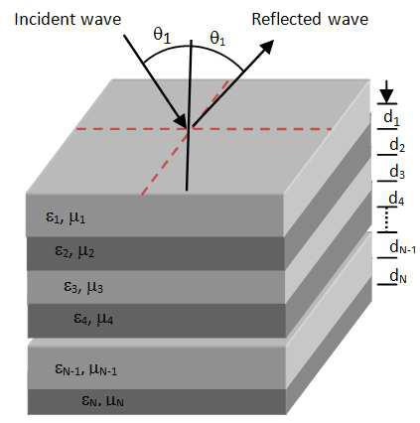

**Figure 2**. Structure of one-dimensional structure 9 [11].

The form of the refractive index in the structure whose layers are in x-y and in the direction of z is given:

𝜖 = { 𝜖1 0<𝑍<�1

2 � <𝑍<�

1 𝜖

# (10)

1 2

𝜖1(�) = 𝜖�(�+�) (11)

Where; l is the number of layer and d is the period. Based on Maxwell's equations and boundaries

conditions The TMM is used, the application of this theory to the transverse components of the electric and magnetic fields for Maxwell's equations for a number of layers to a 1-D structure is divided into two types of polarization, and TE polarization. The TM polarization are given by:

𝐻�� = ���𝑖(��−�𝑙(𝑍𝑙����𝑙+𝑋𝑙�𝑖��𝑙)) + ���𝑖(��−�𝑙(𝑍𝑙����𝑙+𝑋𝑙�𝑖��𝑙)) (12)

𝐸�� = �������(���𝑖(��−�𝑙(𝑍𝑙����𝑙+𝑋𝑙�𝑖��𝑙)) − ���𝑖(��−�𝑙(𝑍𝑙����𝑙+𝑋𝑙�𝑖��𝑙))) (13)

𝐸�� = −�� �����(���𝑖(��−�𝑙(𝑍𝑙����𝑙+𝑋𝑙�𝑖��𝑙)) + ���𝑖(��−�𝑙(𝑍𝑙����𝑙+𝑋𝑙�𝑖��𝑙))) (14)

Where Al and Bl are the amplitudes of the forward and backward travelling waves in the lth layer. The

TE polarization, are given by:

𝐸�� = ���𝑖(��−�𝑙(𝑍𝑙����𝑙+𝑋𝑙�𝑖��𝑙)) + ���𝑖(��+�𝑙(𝑍𝑙����𝑙+𝑋𝑙�𝑖��𝑙)) (15)

IOP Conf. Series: Materials Science and Engineering **518** (2019) 032026

doi:10.1088/1757-899X/518/3/032026

𝐻 = � 𝑙

����𝑙

��

(���

𝑖(��−�𝑙(𝑍𝑙����𝑙+𝑋𝑙�𝑖��𝑙))

− ���

𝑖(��−�𝑙(𝑍𝑙����𝑙+𝑋𝑙�𝑖��𝑙))

# ) (16)

𝐻 = � 𝑙 (� �

�� ����𝑙 �

𝑖(��−�𝑙(𝑍𝑙����𝑙+𝑋𝑙�𝑖��𝑙))

+ ���

𝑖(��−�𝑙(𝑍𝑙����𝑙+𝑋𝑙�𝑖��𝑙))

# ) (17)

The wave numbers and intrinsic impediments are:

𝐾� = �√𝜖0𝜇0𝜖1𝜇1 (18)

� 𝑙

�� = �𝜖 𝜖

1 0

# (19)

By using the boundary condition and the condition for the E and H domains continue in the interfaces.

[𝐸1

𝐸�

𝐻1]=𝑀1𝑀2 … … . 𝑀𝐾 … . 𝑀�−1𝑀 [𝐻�] (20)

The matrix of the 𝑀�−1 lth layer can be written as this formula:

cos(�(�−1)) 𝑖�(�−1)sin(�(�−1))

𝑀(�−1) = [𝑖�−1 sin(�

# ) cos(�

) ] (21)

(�−1)

(�−1)

(�−1)

�(�−1) & �(�−1) matrix parameters are being made depending on the incident angle of light, optical

constants and layer thickness, are expressed as:

�(�−1) = 𝑘(�−1). �(�−1). ����(�−1)

# (22)

�(�−1) = [

� (𝑙−1 )

����(𝑙−1)

# 𝑇𝐸 ����

(23)

�(�−1)����(�−1) 𝑇𝑀 ����

We note that �(�−1) the incidence angle is associated with �0by the Snell’s Descartes low, that:

�(�−1)�𝑖��(�−1) = �0�𝑖��0 (24)

By looking at the transition matrix of each layer, we can get the matrix transmission of the whole

structure.

� 𝑀

�11 �12

# = [

Π�=1 �

�21 �22] (25)

The m11, m12, m21 and m22 are the complex numbers. The transmittance t and reflection r are given

by:

� = (�11+𝑃−1

�

(�11+𝑃−1

�

−1

�12)𝑃−1

�12)𝑃−1

0

0

−(�21+𝑃−1

+(�21+𝑃−1

�

�

�22)

�22)

# (26)

� = 2.𝑃0

0

# (27)

(�11+𝑃−1

�

�

�12)𝑃−1

+(�21+𝑃−1

�22)

The p0 and ps are the first and last medium of the structure which given as

𝑃−1

�

� 0 ��� ��

= { �0

��� ��

���0

# 𝑇𝐸 ����

𝑇𝑀 ����

(28)

𝑃−1

0

� 0 ��� �0

= { �0

��� �0

�0�0

# 𝑇𝐸 ����

𝑇𝑀 ����

(29)

𝑧 = 𝜇0

0 √

𝜖

0

IOP Conf. Series: Materials Science and Engineering **518** (2019) 032026

doi:10.1088/1757-899X/518/3/032026

So the reflection R and transmittance T spectrum can be obtained using expressions:

# 𝑇 = |�|2 (30)

𝑅 = |�|2 (31)

## Result and Discussion

In the transition matrix method for multilayer thin film is used to simulate the transmission through and reflection and absorption from this thin film multilayer. In this research, different wavelengths (300, 700, 1200) nm were incident on the thin film formed by alternating ten layers of glass with a refractive index = 1.4, and a layer of gold with a complex refractive index that found by Drude equation. In the figures (3a,3b,3c) with different thickness (20nm, 50nm, 100nm) for the gold metal found, the transmission is inversely proportional with thickness, the absorption is better behavior in the 50nm thickness, & the reflection individually proportional with thickness.

In the figures (3a,4,5) shows the behavior of the incident wave for thickness 50nm of gold metal and different wavelength 300nm, 700nm, 1200nm. This different region shows that the absorption in the 700nm greater than the 300nm and 1200nm wavelengths, the reflection in the 1200 nm is greater than the 300nm and 700nm wavelengths, & the transmission in the 700nm is greater than 300nm and 1200nm wavelengths.

In the figures (6,7,8) shows the optical coefficient for thin film multilayer S- polarization for different wavelength 300nm,700nm, 1200nm, the optical coefficient (Absorption, Reflection, Transmission) in the 300nm had good result than in 700nm and 1200nm wavelengths.

## The conclusion

In this research, the transfer matrix method used to calculate the optical properties of multilayer thin film. The transmission, reflection, & absorption of the electromagnetic wave EM with different incident angle regime for TM and TE modes were calculated and plotted. We conclude that the Fresnel coefficient affected by the incident angle of the light on the metal. In addition, the best result for this Fresnel coefficient in the visible incident plane wave with wavelength=700nm that had high absorption & reflection.

Fresnel coefficients for transmission (blue), reflection (red) and absorption (green) 1



0.9

0.8

0.7

0.6

Fresnel coefficient

0.5

0.4

0.3

0.2

0.1

0

0 10 20 30 40 50 60 70 80 90

incident angle (degrees)

**Figure 3a**. The relation between the Fresnel coefficient & incident angle (Degree) With wavelength 700nm, the thickness for gold =50nm, p-polarized.

IOP Conf. Series: Materials Science and Engineering **518** (2019) 032026

doi:10.1088/1757-899X/518/3/032026

Fresnel coefficients for transmission (blue), reflection (red) and absorption (green) 1

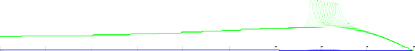

0.9

0.8

0.7

0.6

Fresnel coefficient

0.5

0.4

0.3

0.2

0.1

0

0 10 20 30 40 50 60 70 80 90

incident angle (degrees)

**Figure 3b**. The relation between the Fresnel coefficient & incident angle (Degree) With wavelength 700nm, the thickness for gold =100nm, p- polarized.

Fresnel coefficients for transmission (blue), reflection (red) and absorption (green) 1

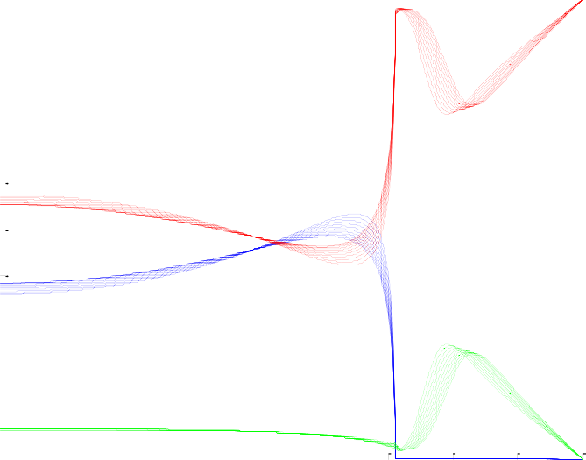

0.9

0.8

0.7

0.6

Fresnel coefficient

0.5

0.4

0.3

0.2

0.1

0

0 10 20 30 40 50 60 70 80 90

incident angle (degrees)

**Figure 3c**. The relation between the Fresnel coefficient & incident angle (Degree) With wavelength 700nm, the thickness for gold =20nm, p-polarized.

IOP Conf. Series: Materials Science and Engineering **518** (2019) 032026

doi:10.1088/1757-899X/518/3/032026

Fresnel coefficients for transmission (blue), reflection (red) and absorption (green) 1

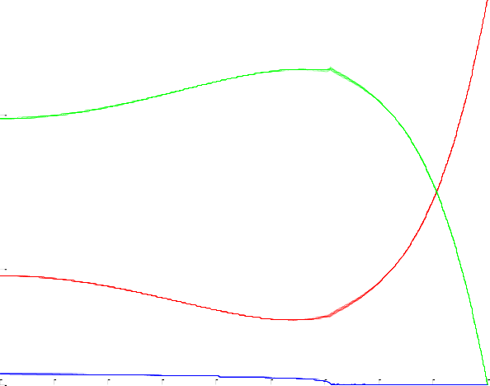

0.9

0.8

0.7

0.6

Fresnel coefficient

0.5

0.4

0.3

0.2

0.1

0

0 10 20 30 40 50 60 70 80 90

incident angle (degrees)

# **Figure 4**. The relation between the Fresnel coefficient & incident angle (degree) With wavelength 300nm, the thickness for gold =50nm, p-polarized.

Fresnel coefficients for transmission (blue), reflection (red) and absorption (green) 1



0.9

0.8

0.7

0.6

Fresnel coefficient

0.5

0.4

0.3

0.2

0.1

0

0 10 20 30 40 50 60 70 80 90

incident angle (degrees)

**Figure 5**. The relation between the Fresnel coefficient & incident angle (degree) With wavelength 1200nm, the thickness for gold =50nm, p-polarized.

IOP Conf. Series: Materials Science and Engineering **518** (2019) 032026

doi:10.1088/1757-899X/518/3/032026

Fresnel coefficients for transmission (blue), reflection (red) and absorption (green) 1

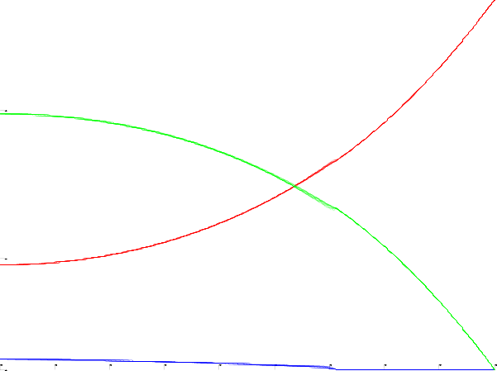

0.9

0.8

0.7

0.6

Fresnel coefficient

0.5

0.4

0.3

0.2

0.1

0

0 10 20 30 40 50 60 70 80 90

incident angle (degrees)

**Figure 6**. The relation between the Fresnel coefficient & incident angle (degree) With wavelength 300nm, the thickness for gold =50nm, S-polarized

Fresnel coefficients for transmission (blue), reflection (red) and absorption (green) 1



0.9

0.8

0.7

0.6

Fresnel coefficient

0.5

0.4

0.3

0.2

0.1

0

0 10 20 30 40 50 60 70 80 90

incident angle (degrees)

**Figure 7**. The relation between the Fresnel coefficient & incident angle (degree) With wavelength 700nm, the thickness for gold =50nm, S-polarized

IOP Conf. Series: Materials Science and Engineering **518** (2019) 032026

doi:10.1088/1757-899X/518/3/032026

Fresnel coefficients for transmission (blue), reflection (red) and absorption (green) 1



0.9

0.8

0.7

0.6

Fresnel coefficient

0.5

0.4

0.3

0.2

0.1

0

0 10 20 30 40 50 60 70 80 90

incident angle (degrees)

**Figure 8**. The relation between the Fresnel coefficient & incident angle (degree) With wavelength 1200nm, the thickness for gold =50nm, S-polarized

## Reference

[1] Hayashi S 2001 Near-Field Optics and Surface Plasmon Polaritons *Topics in Applied Physics* **81**

71.

[2] Lee G J; Lee Y, Jung S G, Jung B Y, Hwangbo C K, Kim S, Park I 2007 Design, fabrication, linear and nonlinear optical properties of metal-dielectric photonic bandgap structures *Journal of Korean Physical Society* **51** 431; (b) Li Z-Y 2005 Principles of the plane-wave transfer- matrix method for photonic crystals *Science and Technology of Advanced Materials* **6** 837- 841.

[3] Aylo R, Nehmetallah G, Li H, Banerjee P P 2014 Multilayer periodic and random metamaterial structures: analysis and applications *IEEE Access* **2** 437-450.

[4] Loot A, Hizhnyakov V 2017 Extension of standard transfer-matrix method for three-wave mixing for plasmonic structures *Applied Physics A* **123** 152; (b) Menzel C, Rockstuhl C, Paul T, Lederer F, Pertsch T 2008 Retrieving effective parameters for metamaterials at oblique incidence. Physical Review B **77** 1953.28.

[5] Shen Y, Ye D, Wang L, Celanovic I, Ran L, Joannopoulos J D, Soljačić M 2014 Metamaterial broadband angular selectivity *Physical Review B* **90** 125422.

[6] Carrera-Escobedo V, Rosu H 2016 Electromagnetic transmittance in alternating material- metamaterial layered structures. arXiv preprint arXiv:1610.0021.

[7] Maghsoodi A, Ohadi A, Sadighi M 2014 Calculation of wave dispersion curves in multilayered composite-metal plates *Shock and Vibration* 2014.

[8] Griffiths D J 2005 *Introduction to electrodynamics* AAPT.

[9] Hecht E 2002 *Optics* (4th edn). San Francisco: Addison Wesley.

[10] Byrnes S J 2016 *Multilayer optical calculations*. arXiv preprint arXiv:1603.02720. [11] Fowles G R 1975 *Introduction to modern optics* Courier Corporation.

[12] Born M, Wolf E 2013 Principles of optics: electromagnetic theory of propagation, interference and diffraction of light. Elsevier.